STEVEN SCHUTZBANK DPM PA
- BILLING SOFTWARE & LOGINS:
- PMS: Office Ally
User: SSchutzbank
Password: Winter#2025

Gmail ID for the provider - officebillersschutzbank@gmail.com
Password – 1127Medeye

Email ID: officebillersteven@gmail.com
Password: Medeye@1127

- General Billing & CPT updates
Note* Medeye started billing from DOS 08/21/2024 (work date-08/26/2024).

- Medicare’s LCD: Article - Billing and Coding: Routine Foot Care (A52996) (cms.gov)
- Need to bill on POS 14 & 11(according to given superbill facility or office visit)
- Need to add facility according to received charges
- Need to Hold all HMO/PPO claims/Commercial
- If we did not find any last seen date on superbill use the DOS as last seen date
- Check PCP in eligibility if given then add them as referring, if not found any PCP, then add self (provider Steven Schutzbank) as referring provider
- If patient have secondary insurance Commonwealth of Pennsylvania, then we need to write off the secondary amount as per provider email received on 11/26/2024
- Before send patient statement to provider 1st, we need to check whether the patient have secondary Medicaid or not; if yes, then bill to Medicaid and if not, then we need to adjust the amount (Email received on 11/8/2024)
- Most of them have Medicaid secondary and they only pay if we do not receive a payment so we need to write of the claim after received denial from insurance (email received on 11/08/2024.
- Hold Medicare claim till June as per provider msg received on 03/12/2025 superbills
- Patient statement only sent to provider office, once confirmation receive from provider office then we will send to statements to patient
- If we received CPT 99202/99212 in UPMC plan so kindly use U& modifier otherwise insurance will deny the claim due “PROCEDURE CODE NOT ON MA FEE SCHEDULE OR IS INVALID FOR THIS PROVIDER TYPE”
- 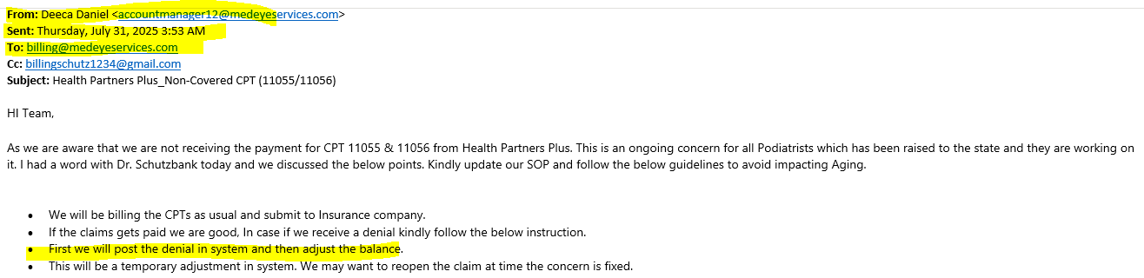

We need to adjust the balance of CPT 11055/11056/11057 after denial received from Health partner insurance due to CPT not covered under patient’s plan

- PROVIDER BILLING INFORMATION:

Billing Information
Practice Name | STEVEN SCHUTZBANK
Tax ID/SSN | 195425747
Individual NPI | 1033168380
Taxonomy | 213EP1101X
Specialty | Podiatrist
PTAN-Ind | 094624
Address | 7341 BROOKHAVEN RD  PHILA, PA 19151-2206
Ph# | 215-473-1070
Fax# | 215-871-3668
Rendering Provider | Dr. STEVEN SCHUTZBANK
Provider Email | billingschutz1234@gmail.com

- Credentialing /Networking Status:

Insurance | Network Status | Remarks
Aetna | OON
BCBS | NA | We need to send an email to confirm the status
Bravo Health | NA | Currently, Bravo Health is not connectable. I attempted to reach them by phone, but the calls were disconnected due to a system error. I will need to try contacting them again
Cigna | INN | Start Date - 08/01/2003
Health Partners | OON | The provider needs to send the LOI and W9 for credentialing. Reference ID: 01929269/Deven.
Humana | INN | Start Date - 06/06/2024, End Date - 06/07/2027
Independence BCBS | NA | Not connectable. We need to send an email to confirm the network status
Independent Health PA | OON
Medicaid | INN
Medicare | INN
Tricare East | OON
UHC | INN

ERA set up status update received on 12/06/2024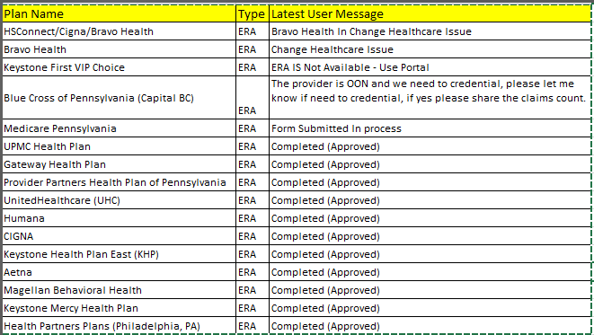

Community Behavioral Health
Claim Mailing address: 801 Market Street Philadelphia, Pennsylvania 19107.
Fax# 215-413-8591
Email - cbh.clinicalrequests@phila.gov

TFL List
Insurance Name | Payor ID | TFL
AARP- Medicare Supplement | 36273 | 15 months from DOS
Aetna | 60054 | 120 days for IIN and 365 days for OON
Ambetter | 68069 | 180 days for IIN and 90 days for OON
BCBS Empire | 803 | Need Member Id card as unable to get connected to correct department
BCBS Pennsylvania (Highmark) | 54771 | Need Member Id card as unable to get connected to correct department
Blue Cross of Pennsylvania (Capital BC) | 23045 | Need Member Id card as unable to get connected to correct department
Bravo Health | 63092 | Need Member Id card as unable to get connected to correct department
CareFirst BCBS | SB580 | Need Member Id card as unable to get connected to correct department
CIGNA - PPO | 62308 | 90 days from DOS
Devoted Health | DEVOT | 90 Days for IIN and 365 days for OON from DOS, Our provider is OON
Gateway Health Plan - Medicare Assrd | 60550 | 365 days from DOS
Health Partners Plans (Philadelphia, PA) | 80142 | 180 days from DOS
Humana | 61101 | 365 days from DOS
Independence Administrators | 54763 | 365 days from DOS
Independence Blue Cross (Highmark) | 54704 | 365 days from DOS
Keystone First Community Health Choices | 42344 | 180 days from DOS
Keystone First VIP Choice | 77741 | 365 days from DOS
Keystone Health Plan East-BC | 95056 | 365 days from DOS
Keystone Mercy | 23284 | 180 days from DOS
Medicaid Pennsylvania | MCDPA | 180 days from DOS
PA Health and Wellness (Centene) | 68069 | 180 days from DOS
Provider Partners Health Plan of Pennsylvania | 31400 | 90 days from DOS
SGIC | 11789 | Need Member Id card as unable to get connected to correct department
Trustmark Health Benefits | 38225 | Need Member Id card as unable to get connected to correct department
United HealthCare | 87726 | 180 days from DOS
UnitedHealthcare Community Plan NE, NM, NY, OH, PA | 87726 | 180 days from DOS
UPMC Health Plan | 23281 | 180 days from DOS

Medicaid E&M claims with Modifier U7

With the implementation of the ACCESS Plus Program, podiatrists are reminded that pricing modifier U7 is required to be billed with the following national procedure codes to ensure the appropriate payment rate. National Procedure Code National Procedure Code National Procedure Code National Procedure Code 99202 99203 99204 99205 99212 99213 99214 99215 99347 99348 99349 Podiatrists who render services to M A recipients in the fee-for-service delivery system are directed to refer to the attached

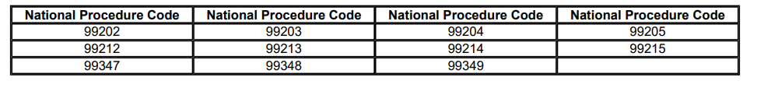

- GROUP RETIREE HEALTH SOLUTIONS, INC. is affiliated with Blue Medicare Advantage. Based on information, the claim should be submitted to Independence Blue Cross (Highmark). Payer ID: 54704.

